**E Tendering and Monitoring**

### Saif Muzaffar

### Muhammad Bilal



DEPARTMENT OF COMPUTER SCIENCES COMSATS UNIVERSITY ISLAMABAD, ATTOCK CAMPUS – PAKISTAN

SESSION 2017-2021

**E Tendering and Monitoring**

*Undertaken by*

## Saif Muzaffar

CIIT/FA17-BCS-102/ATK

## Muhammad Bilal

CIIT/FA17-BCS-080/ATK

*Supervised By:*

### Miss Sadia Ejaz

A DISSERTATION SUBMITTED AS A PARTIAL FULFILLMENT OF THE REQUIREMENTS FOR THE DEGREE OF BACHELOR OF COMPUTER SCIENCE

DEPARTMENT OF COMPUTER SCIENCES COMSATS UNIVERSITY ISLAMABAD, ATTOCK CAMPUS – PAKISTAN

SESSION 2017-2021

UNDERTAKEN

We certify that this is my/our work. The work has not, in whole or in part, been presented elsewhere for assessment. Where material has been used from other sources it has been properly acknowledged. If this statement is untrue, we acknowledge that we will have committed an assessment offence and shall be liable to punishable action under the plagiarism rules of HEC.

Saif Muzaffar Muhammad Bilal

FA17-BCS-102 FA17-BCS-080

Dated: Dated:

# FINAL APPROVAL

Certified that we have read this E tendering and Monitoring project report submitted by Mr. (Saif Muzaffar, Muhammad Bilal) and it is, in our judgment, of sufficient standard to warrant its acceptance by the Department of Computer Science, University of Islamabad, Attock Cantt, for the (BS/MSc degree) in Computer Science.

***Committee:***

1. External Examiner (Examiner Name)

Designation University Name

1. Supervisor (Supervisor Name)
2. Chairperson

(Chairperson Name)

1. Dean/Director

(Dean/Director Name)

**DEDICATION**

**Every challenging work needs self-effects as well as the guidance of elders especially those who were very close to our hearts. My humble efforts I dedicate to my sweet and loving.**

**ALLAH**

**My creator my strong pillar, my source of inspiration, wisdom, knowledge, and understanding.**

**Father and mother**

**Whose affection, love, encourage and prays of day and night make me able to get such success and honor.**

**Teachers**

**Along with all hardworking and respected teachers.**

# Acknowledgement

All applause is to Almighty Allah who gave to us a brief part of His limitless information by temperance of which we had the option to achieve this difficult errand. We are significantly obligated to our venture boss "**Miss Sadia Ejaz**". Without her management, exhortation and significant direction, fulfillment of this task would have been suspicious. We are profoundly obliged to them for their consolation and constant assistance during this work. What's more, we are additionally appreciative to our folks and family who have been a consistent wellspring of support for us and presented to us the estimations of trustworthiness and difficult work.

Saif Muzaffar Muhammad Bilal

**PROJECT BRIEF**

PROJECT NAME E TENDERING AND MONITORING

ORGANIZATION NAME COMSATS UNIVERSITY ISLAMABAD,

ATTOCK CAMPUS

OBJECTIVE TO PROVIDE EASE TO CONSTRUCTORS MAKE REGISTER WORK DIGITALLY AND BIDING SYSTEM ONLINE AND MONITOR THE WORK ONLINE.

UNDERTAKEN BY SAIF MUZAFFAR, MUHAMMAD BILAL

SUPERVISED BY MISS SADIA EJAZ COMPUTER SCIENCE

COMSATS UNIVERSITY ISLAMABAD, ATTOCK CAMPUS

STARTED IN SEPTEMBER 2017

COMPLETED ON MAY 2021

COMPUTER USED HP (ELITEBOOK 8470P) SOURCE LANGUAGE JAVA, XML

OPERATING SYSTEM WINDOW 10

TOOLS USED ANDROID STUDIO 4.0.1

**ABSTRACT**

We are well aware of the tendering system in Attock, which is a very hectic task for contractors. Every contractor has a very difficult and hectic job to win the bidding session, the contractors have to travel miles for just the entry for bidding. So we are coming with an idea for the ease of contractors, our project will help contractors and will save time and headaches for contractors. Our project will help them and contractors will be able to apply for bidding through our project which will save the time and travel of contractors. The bidding will also be done online through an application. The bidding sheet will be uploaded on our application for contractors. For the whole process Construction Company have to sign up for our application. Users can fill the bidding sheet online and it will save the hard work of the user. The low rate bid will automatically come to the top of the list of bidders in front of the PUBLIC HEALTH DEPARTMENT view. When the tender is issued to the registered company then we monitor the work of the issued tender for the site where the work has been in progress by the laboratory test of the material used in the work. On the behalf of the test issued by the laboratory we have to approve/disapprove the work and then the bills are generated.

**Table of Content**

1. Introduction 18
   1. Brief 18
   2. Relevance to Course Modules 19
   3. Project Background 20
   4. Literature Review 21
   5. Analysis from Literature Review 21
      1. Problem identify in current portal 21
      2. Comparative Analysis……………………………………………………………..22
   6. Methodology and Software Lifecycle for this Project 22

1.7 Rationale behind selected methodology 23

1. Problem Definition 25
   1. Problem Statement 25
   2. Deliverables and Development Requirements 25
      1. Software Specification 25
      2. Hardware Requirement 26
      3. Tools 26
   3. Current System 26
2. Requirement Analysis 29
   1. Use Case Diagram 29
      1. Detailed Use Case Diagram 30
   2. Requirement Specifications 30
   3. Non-Functional Requirement 31
      1. Performance 31
      2. Accuracy 31
      3. Maintenance 31
      4. Efficiency 31
      5. Integrity 31
      6. User Friendly 31
      7. Reliability 31
   4. Functional Requirement 31
3. Design and Architecture 34
   1. Life Cycle of Android Application 35
      1. Active and Running State 35
      2. Paused State 35
      3. Stopped State 36
      4. Dead or Destroyed State 36
   2. Data Representation [Diagram + Description] 37
   3. Process Flow / Representation 37
      1. Activity Diagram 38
   4. Design Models 39
      1. Sequence Diagram 39
   5. DFD Levels Diagrams 42
4. Implementation 45
   1. Tools and Technologies 45
      1. Tools 45
      2. Languages 45
      3. Database45
   2. Development Stages 45
      1. Payment method integration ( jazz cash) 45
      2. Calculations 46
   3. User Interface 46
      1. Splash Screen 46
      2. Login page 47
      3. Signup 48
      4. Email Verification 48
      5. Forget Password 49
      6. Dashboard Screen and navigation bar 50
      7. Profile 51
      8. Search and tender 52
      9. Monitoring 56
      10. Billing 57
      11. Work Done 58
   4. Admin Interface 59
      1. Tender Admin 59
      2. Monitoring Admin 62
      3. Billing Admin 63
5. Testing and Evaluation 65
   1. Manual Testing 65
      1. System testing 65
      2. Unit testing 65
      3. Function testing 66
6. Conclusion and Future Work 76
   1. Conclusion 76
   2. Future work 76
7. References 78

**List of figures**

Figure 1-1 Iterative Model 22

Figure 1-2 Use case Diagram 30

Figure 1-3 System Architecture 34

Figure 1-4 Android Life Cycle 35

Figure 1-5 Data Flow 37

Figure 1-6 Activity Diagram 38

Figure 1-7 Sequence Diagram for Login 39

Figure 1-8 Sequence Diagram for Registration 40

Figure 1-9 Sequence Diagram for Tender Search 40

Figure 1-10 Sequence Diagram for Monitoring 41

Figure 1-11 Sequence Diagram for Billing 41

Figure 1-12 Sequence Diagram for Bidding 42

Figure 1-13 System DFD Level 0 42

Figure 1-14 System DFD Level 1 User Login 43

Figure 1-15  System DFD Level 2 User. 43

Figure 1-16  Splash Screen. 46

Figure 1-17  Login Page. 47

Figure 1-18  Signup Page. 48

Figure 1-19  Email Verification. 48

Figure 1-20  Forget Password. 49

Figure 1-21  Reset Password Email. 49

Figure 1-22  Dashboard Screen and navigation bar. 50

Figure 1-23  Profile. 51

Figure 1-24  Search Tender and tenders. 52

Figure 1-25  Tender Details and bid sheet. 53

Figure 1-26  Jazz Cash and sending tender fee. 54

Figure 1-27  bidding on tender. 55

Figure 1-28  Monitoring. 56

Figure 1-29  Billing. 57

Figure 1-30  Work Done. 58

Figure 1-31  Tender Admin. 59

Figure 1-32  Bid Sheet Details. 60

Figure 1-33  Add Tender Details. 60

Figure 1-34  Add Tender. 61

Figure 1-35  Bids and Notifications. 61

Figure 1-36  Monitoring Admin. 62

Figure 1-37  Monitoring and Feedback. 62

Figure 1-38  Billing Admin. 63

**List of Tables**

Table 1-1 Comparative study 22

Table 3-1 User view info use case 30

Table 6-1 User sign in 66

Table 6-2 User signup 67

Table 6-3 Search tender 67

Table 6-4 User tender 68

Table 6-5 User bid on tender 68

Table 6-6 User monitoring 69

Table 6-7 User Billing 69

Table 6-8 User work done 70

Table 6-9 User navigation 70

Table 6-10 Log out 71

Table 6-11 Tender Admin 71

Table 6-12 Monitoring Admin 72

Table 6-13 Billing Admin 73

# Chapter 1 INTRODUCTION

### Introduction

E Tendering and monitoring is a cycle of doing whole Tendering Cycle Online including accommodation of value offer, checking of work progress, giving of bills with the end goal that Efficiency, Economy, and Speed of Internet can be saddled. We are developing an Android application that will monitor the process and progress. Contractors will be able to communicate with public health authorities through the app. Contractors will have a nice and easy interface to bid and receive bid forms. The department will be able to check progress, place bids, replay to contractors, check the progress by laboratory reports, generating the bills, etc. Android apps will have many features that can make stakeholders entertain. This can save a lot of time and money for travel and traditional meetings. Most importantly, it will save energy and people will be able to spend a good time with their families.

### Brief

We often get to hear that the businessmen are always busy having meetings and we usually find them on calls. Sundays and Holidays are no for them. It is saying that the more and the big business are the less burden you will face. But in either of these cases, there are problems. Like if the business is on small scale, the workers will have to work more. If the business is on large scale, then more people will be doing work that costs more. Literally, in every case, there are either labor or cost problems. So we came up with a solution. Everybody uses smartphones. Our idea is to replace some parts with smartphones. We are developing an Android app that will monitor the processes and progress. The contractor would be able to communicate with the public health department through the app. The contractor will have a nice and easy interface to bid and receiving the bidding sheets. While the Department will be able to check the progress, make bids, replay to contractors, etc. Android application will have a lot of features to entertain the stakeholders. This will save a lot of time and money that is spent on travel and traditional meetings etc. Above all, it will save energy and people will be able to spend some time with their family. We belong to a society where business is the most common profession and people indulged themselves completely into it. So this motivates us to bring ease to this field by taking away the worries and problems by removing unnecessary traditional tasks that have been followed. This application will shift the business on technology, change the directions of worries and give the business a boost.

### Relevance to Course Modules

In Computer Science we study theoretical aspects of computer technology and computer usages. The Principal and areas of studies in Computer Science have included computer architecture and networking, cyber-security, database management system, human-computer interaction(HCI), graphics, numerical computation, programming languages (JAVA, etc.), software engineering, and theories of the computer’s world.

This project is an android based application. Utilizing different modules this application is relevant to different courses like, using JAVA programming language backend will be developed, using XML frontend will be designed, and firebase database will be used for storing data, data sending or retrieving from the database. There have so many relevant modules and work which is related to BCS courses if we focus on little bit things one by one.

#### Android development

Android Studio is the IDE that provides Google to develop professional Android applications. It is used to develop a different variety of applications for the Android operating system. It is an IDE & platform to design a user-friendly interface by drag and drop.

#### Java

Java is a class-based, object-arranged programming language designed to have execution conditions that do not exceed reasonable expectations as much as possible. It is a widely-used programming language. It is recommended that application engineers write it once and run it anywhere (WORA), which means that the assembled Java code can be run at all stages of helping Java without recompilation. Java applications are usually accumulated as byte code, which can be run on any Java Virtual Machine (JVM), with little attention to basic PC engineering. The sentence structure of Java is similar to that of C and C++ but has fewer low-level offices than these two. The Java runtime provides dynamic features (for example, reflection and runtime code adjustment), which are usually inaccessible in dialects that are customary to collect. Starting in 2019, Java is one of the most famous programming dialects used by GitHub, especially for customer worker web applications, with a detailed 9 million engineers.

#### Report Writing Skills

This course is about learning how to write reports and other formal documentation, and, in our project, we need to write our documentation, so this course is helping a lot in this task.

#### Software Engineering

Software engineering is the systematic application of engineering methods in software development.

### Project Background

### We have a place with a general public where business is the most regular calling and individuals entertained themselves totally into it. So this spurs us to get facilitate this recorded by taking the concerns and issues by eliminating pointless conventional undertakings that have been followed. This use of our own will move the business on innovation, change the headings of stresses and give the business a lift. We as a whole skill organization works and everyone needs an agreeable employment climate and arranged life. Our task will have the option to show all the offer sheets running as of now to the contractual workers. It will make contractual workers’ pay on the app or bid on the app. The notification will be shipped off to the person who has won the offer. The person who bid on the offer but doesn’t win the offer gets the notification “sorry try next time”.

### We are well aware of the tendering system in Attock, which is a very hectic task for contractors. Every contractor has a very difficult and hectic job to win the bidding session, the contractor has to travel miles for just the entry for bidding. So we are coming with an idea for the ease of contractors, our project will help contractors and will save time and headaches for contractors. Our project will help them and contractors will be able to apply for bidding through our project which will save the time and travel of contractors. The bidding will also be done online through an application. The bidding sheet will be uploaded on our application for contractors. For the whole process Construction Company have to sign up in our application. Users can fill the bidding sheet online and it will save the hard work of the user. The low rate bid will automatically come to the top of the list of bidders in front of the PUBLIC HEALTH DEPARTMENT view. When the tender is issued to the registered company then we monitor the work of the issued tender for the site where the work has been in progress by the laboratory test of the material used in the work. On the behalf of the test issued by the laboratory we have to approve/disapprove the work and then the bills are generated.

### Literature Review

We see the different websites and android apps that show just tender information. There is an android app in South Africa in which they just show the tender information and upcoming tenders. In Pakistan (KPK) the e-tendering app use in the NHA department but in Punjab, there is no such application. So we are working on this application for the PHE department (Punjab). The reason why our project is different from others. In KPK e-tendering app the user registers companies and gets information of upcoming tenders. The user can bid on the tender but department admins cannot monitor their work online.

### Analysis from Literature Review

#### The existing e-tendering applications just welcome the user to show the details of the tender and the user gets updates about the upcoming tender. The existing websites also just show the tender updates and upcoming tenders. As compared to those applications our app user can view tender details, bid on tender, get notifications about tenders, and the admin also monitors the working online. They provide information about the tenders.

#### Problem identify in current portal

* The electronic tendering app made by the NHA department is implemented only in KPK.
* The electronic tendering app was failed in Punjab because Punjab projects are different from KPK.
* The current android app just shows the information about tenders.
* Users cannot bid on the bid sheet online.
* The user cannot get notifications about tenders or winning tender.

#### Comparative Analysis

**Comparative study table:**

**Table 1-1 Comparative study**

|  |  |  |  |  |
| --- | --- | --- | --- | --- |
| **Company** | **Difficult UI** | **Bid-on-tender (ONLINE)** | **Application Notification** | **PUNJAB (PHE)** |
| **E-tendering (NHA)** | **YES** | **NO** | **NO** | **NO** |
| E-tendering (ours) | **NO** | **YES** | **YES** | **YES** |

### Methodology and Software Lifecycle for this Project

First of all, the user goes to sign up and register their company, after registration user can log in to their id by verifying their email address. When the user login to the application there is a dashboard screen from where the user searches tender or bid on tender online. After bidding on tender the tender admin calculates and assigns tender the user gets the notification about the winning and losing tender. After the winning of the tender, our system will monitor the work wined by the user and the user will update us about the work by the consulted laboratory tests. We use an iterative approach to develop this application.

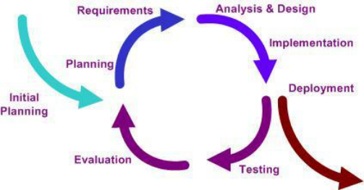

*Figure 1-1 Iterative Model*

### Rationale behind selected methodology

In this model, you can start with some of the software specifications and develop the first version of the software. After the first version if there is a need to change the software, then a new version of the software is created with a new iteration. Every release of the Iterative Model finishes in an exact and fixed period that is called iteration. The reason behind this approach is that it is easily measurable and small chunks are easy to test and debug as compare to developing the whole software and then testing it, at this point debugging becomes difficult. So, we would like to work under a supervisor because we want to learn more about our project and if the supervisor wants some changes or an updated project then we can easily make the changes in the new version.

# Chapter 2 PROBLEM DEFINITION

### Problem Definition

We belong to a society where business is the most common profession and people indulged themselves completely into it. So this motivates us to bring ease to this field by taking away the worries and problems by removing unnecessary traditional tasks that have been followed. This application will shift the business on technology, change the directions of worries and give the business a boost. We all know how businesses works and everybody wants a comfortable job environment and sorted life.

* 1. **Problem Statement**

The major reason is, we are very much aware of offering framework in Attock, which is a feverish undertaking for temporary workers. Each contractual worker has an exceptionally troublesome and chaotic task to win the offering meeting, a contract-based worker needs to travel miles for simply the passage for the offering. So we are accompanying a thought for the simplicity of temporary workers, our venture will support contract-based workers and will spare the time and migraine of contract-based workers. Our venture will support them and temporary workers will have the option to apply for offering through our task which will spare the time and travel of temporary workers. The offering will likewise be done online through the application.

### Deliverables and Development Requirements

The propose system we are going to developed is android base so, keeping on mind the development requirements have hardware and software requirements which is given below:

### Software Specification

* **Operating System**
* Windows
* **Development**
* Android Studio
* **Front-End Design**
* XML

Extensible Mark-up Language (XML) used for describing data. Basic of XML syntax well be helpful for designing interactive interface, layouts and perceiving data/info feeds from internet. It is basically used for designing the whole frame of application including buttons, layouts, sidebar, searching design etc.

* **Back end**
* Java

The backend rationale will be created by utilizing java in our task. Essential structure square of android application advancement is the programming language which is java. Java gets one of the most mainstream programming advancement dialects utilized by programming designers in this day and age.

### Hardware Requirements

* Intel i5-core with 2.7 processor
* 8.00 GB Installed memory
* Android Smart Phone

### Tools

* Android Studio and SDK (Designing and Development)
* Star UML (for designing Diagrams)
* Database Firebase
* Java Programming language

## Current System

By considering related issues there have many applications that have been developed by different developers the thing is that this developed application has some constraints utilizing interactive, generalize, user-friendly, and specified for specifics regions.

* **South Africa Online tenders**

In this online tender system, the user can search the tender by the id or place in South Africa and the application have the functionality of a calendar in which the user finds news of tender and upcoming updates. But there is no bidding option online the user comes to the department and fills the rates of tenders.

* **KPK NFA tender system**

KPK tender system is based on the online projects in which the user first registers their company and login their account and find the tenders in tender box. If the user wants to bid, there is also an option of biding but after biding the user must come to the department for their checks and finding that they win or lose the tender. The department monitor the work manually for example the department officer goes to the site and monitor the work.

# Chapter 3 REQUIREMENT ANALYSIS

### Requirement Analysis

We'll clarify the use case chart, practical necessities, and non-useful prerequisites of the proposed system. Functional requirements explain the system its components. Functional requirements would also explain in upcoming chapters by using different pictures and diagrams. Functional requirements will also describe the behavior of the system. A non-functional requirement is a requirement that specifies existing criteria that could be used to operate a system that deals with reliability etc., rather than specific behaviors that the application must do.

### Use Case Diagram

A sensible image of the associations among the segments of a structure is called a use case outline. A use case diagram is a technique utilized as a part of framework investigation to perceive and arrange framework necessities. We design UML (Unified Modelling Language) figures to model a framework simply and efficiently. UML describes several types of the diagram to cover all aspects of the framework because it is not enough to define all aspects of the system using single UML diagram.

The user-case system diagram defines the relationship between the user of the system (Actor) and the functionality of the system. It is also known as the behavior diagram. It identifies the different users and the functionalities of the system and the relationship between them.

Use case system diagram describe the actor, use-case and the system.

* **User (Actor):** System user.
* **Use-case (Diagram)**: Indicate System Functionality.
* **System:** System is the block that contains the use cases

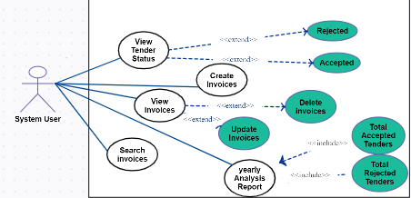

*Figure 1-2 Use Case Diagram*

#### Detailed Use Case Diagram

**Table 3-1 User view info use case**

|  |  |
| --- | --- |
| Use Case Id | User ID |
| Use Case Name | View information |
| Actor | Company/User |
| Summary | System provides all information to user. |
| Precondition | User must have internet access. |
| Include | None |
| Extend | Tenders, Bidding, View Bid Sheet, Monitoring etc. |

### Requirement Specifications

Requirements specification describes functional requirement and non-functional requirements explain system its components respectively. Functional requirements would also explain in upcoming chapters by using different pictures and diagrams. Functional requirements will also describe the behavior of the system. A non-functional requirement is a requirement that specifies existing criteria that could be used to operate a system that deals with reliability etc., rather than specific behaviors that the application must do.

### Non-Functional Requirement

#### Performance

No delay in execution and show result quickly.

### Accuracy

Provide authentic and concrete information’s.

### Maintenance

For maintenance it is easy to change the system according to his own requirements.

### Efficiency

The proposed system is time efficient and gives the users required output without any delay.

### **Integrity**

System stored data will accurate, good and updated.

### **User Friendly**

The interface of system will be user friendly and easy to use so that all users can easily access this application and can get recommendation if not now about famous places.

### **Reliability**

System will be able to be used for long time. This application must perform its intended functions and operations without experiencing failure.

### Functional Requirement

If we discuss Functional requirements, then it describes the functionality of the proposed system. E tendering app consists of different modules. Each module has its functional requirements. Following are the given modules of the E tendering android app.

* Admin panel
* Company panel/user panel
* Calculation
* Login
* Registration
* Biding
* Monitoring

### Admin Panel

Admin can perform following functionalities.

* Login via email and password
* Change the password
* Delete records of users from database.
* View record of the user.
* Update/Add/Delete/View the details of users.
* Upload Bid sheet.
* Monitoring

### Company/Users

User can perform following functionalities.

* User can view the details of Tenders.
* User can search the tenders.
* User can bid the tender.
* User can view their profile.
* User can view useful information.
* User can contact us.

### Login

* Users login to the system by entering his/her email and password to getting access of system. Without valid email they will not be able to login.

### Registration

* If user want to use the application then he/she must be registered, unregistered user can’t view tenders or bid sheet doesn’t get recommendation. To get registered a user must enter their whole personal information which are asked by this application. Without entering the correct/real personal information user can’t be registered

# Chapter 4

**DESIGN AND ARCHITECTURE**

## Design and Architecture

The Android working framework comprises various layers as appeared beneath. These layers incorporate diverse sorts of utilization, various libraries, a bit of Linux which is the center of OS, the system of use and the latter is runtime android. The first layer is called the android application layer in any android framework. Here we can locate some significant elements like short informing administration application, maps, program, contacts, electronic mail applications, calls.

The second layer of android working framework design is outline work of use. It is the diagram of the structure utilizes by programming engineers. The application interface is accessible for advancement reasons and it comprises fundamental instruments and uses to make the more intricate application in android.

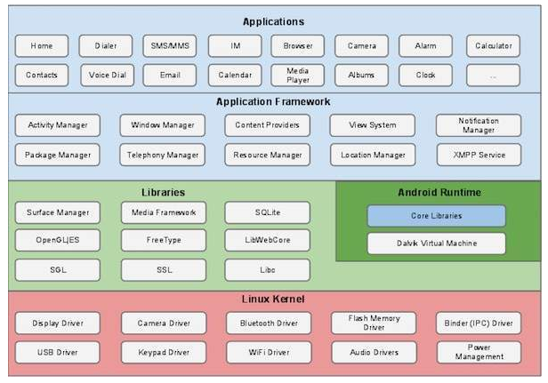

Figure 1-3: System Architecture

These layers will be used by different android system components for different components. The developer uses these available libraries for different tasks or reuse system functionality. Layer-fourth of the system is the android runtime. It is special software which creates new processes independently for android application. The last and fifth layer is the Linux kernel in android architecture. The framework is used for system’s memories management, to access system files, and different inter-system processes of communication, power management software, and networking.

### Life Cycle of Android Application

Android application has four states as described below:

### Active and Running State

In this state action runs in front and shows center around it. Client utilizes this movement and discernible totally.

### Paused State

In paused state, the program is halfway recognizable to the client however it isn't obvious to the client and centered. At the point when some other action runs which doesn't conceal the entire screen then this occurred.

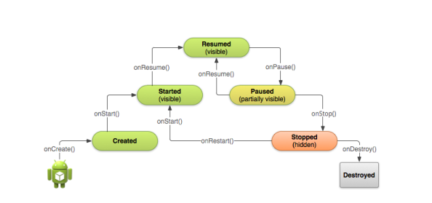

*Figure 1-4: Android life cycle*

### Stopped State

### A stopped state is considered when the principal screen isn't demonstrating any movement. The view is hazy and another movement running behind it. In this express, the movement running in foundation utilizes assets like memory and so forth, yet it very well may be halted by the task supervisor where we have accessible choices to clear the running application.

### Dead or Destroyed State

When running application has not anymore in memory called a wrecked state? It very well might be the application was not opened at this point previously or after beginning the application is cleared from memory to spare memory assets.

In android life cycle streaming capacity have performed which is the show in the above figure

1. Starting an action in the android telephone, it calls the onCreate () work. This capacity instates the information basics and makes UI.
2. **OnStar** () capacity will be called even client has not seen the movement yet. The action is as yet halted so we should know why.
3. **On Resume** () work client can connect with movement and can see it on a telephone screen. In stack, the situation of movement will be on the highest point of the stack. Presently application is running and the client gives input.
4. **On Pause** () capacity could be gotten to when it is in the dynamic express; the application is prepared to continue when the client presses the home catch or one other action is running on top.
5. **On Stop** () work when action is not, at this point obvious to the client on screen, it will be entered halted state and on Stop () work summoned. This may have happened when new action open and cover the entire screen. At the point when the movement has gone to complete the process of running and will going to end.
6. **On Destroy** () capacity will be called before the action is the crush. On the two cases framework conjure this get back to either movement is completing because of client totally excuse the action and the framework is briefly crushing the action because of framework arrangement changed. At the point when the action moves to demolish state, the life cycle will get the on Destroy occasion. The life cycle will tidy up before annihilating the movement.

### Data Representation [Diagram + Description]

Following are the given modules consist of the product which goes to be developing. We are documenting only the salient/customer properties and methods of every module to keep the description more readable and simple.

|  |  |
| --- | --- |
| External Entity | Description: dfd Xt |
|  |  |
| Process/Function | Description: dfd process |
| Data Source | Description: dfd d  *Figure 1-5: Data Flow* |

* **External Entity**

External entity is the user of proposed system who is interacting with the system to use different functionalities off the system.

* **Process/Function**

It is the functionality of the system

* **Data Source**

Data source is the data table in the database where the record is stored, or record is retrieved.

### Process Flow / Representation

In process flow diagram we will represent DFD and Sequence diagram for all modules which is given below.

Methodology is a systematic process to make the development of software easy, in which we divide our project into different phases which are related to each other. There are many methodologies but we used Waterfall development approach.

#### Activity Diagram

Activity diagrams are graphical representations of the workflow of system modules.Activity diagrams are constructed by using the different number of shapes, connected with arrows. The most important shape types:

* Actions represent by rounded rectangles.
* Decisions represent by a diamond shape.
* The first node represents the initial node of the workflow.
* Last node represents the final node.

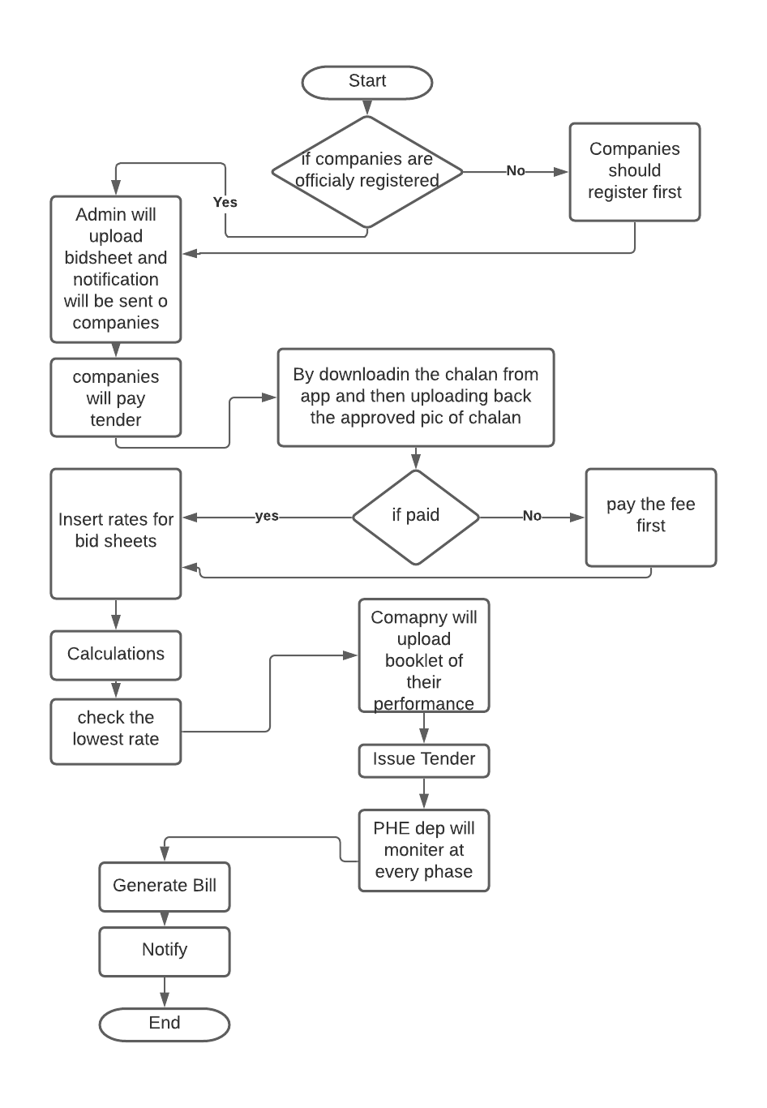

*Figure 1-6 Activity Diagram*

### Design Models

#### Sequence Diagram

Sequence diagram is basically representing the interaction of different object in a specific order. It describes the sequence of the exchange of messages between the objects.

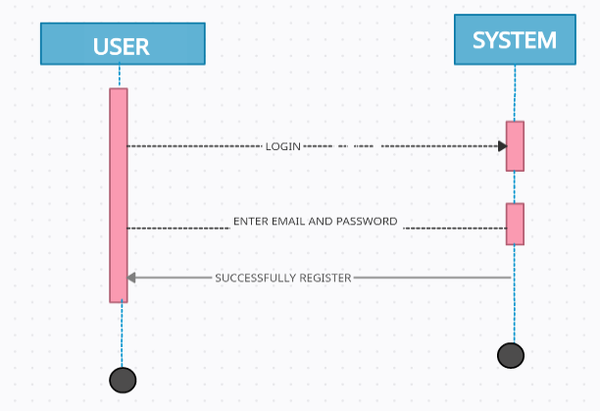

*Figure 1-7 Sequence Diagram for login*

User goes to login area. After the authentication from database user login in the system and have different option to perform different task as describe in above Fig.

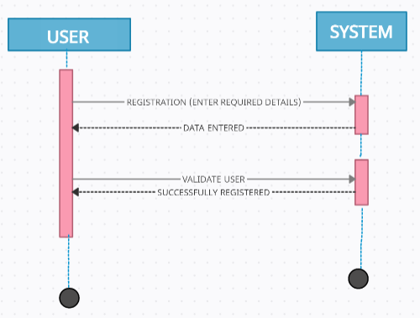

*Figure 1-8 Sequence Diagram for Registration*

User goes to register area. After the registration complete from database user login in the system and have different option to perform different task as describe in above fig.

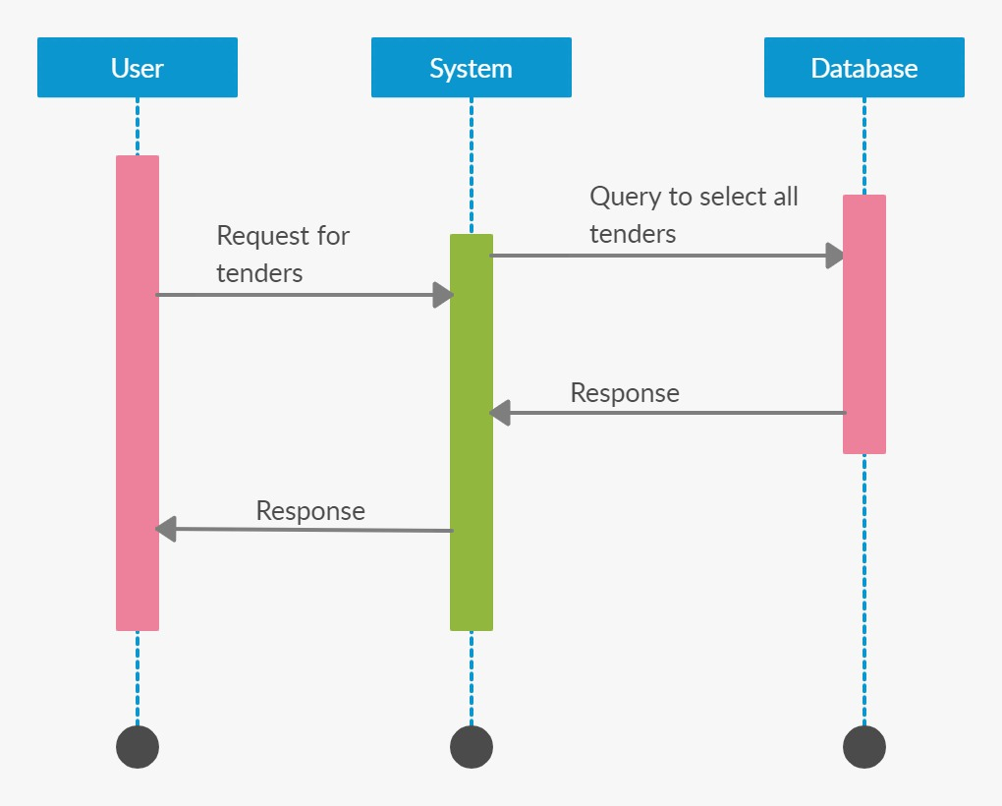

*Figure 1-9 Sequence Diagram for Tender Search*

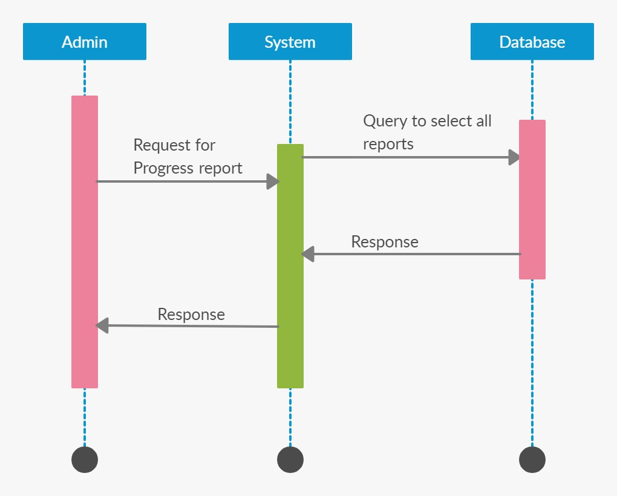

*Figure 1-10 Sequence Diagram for Monitoring*

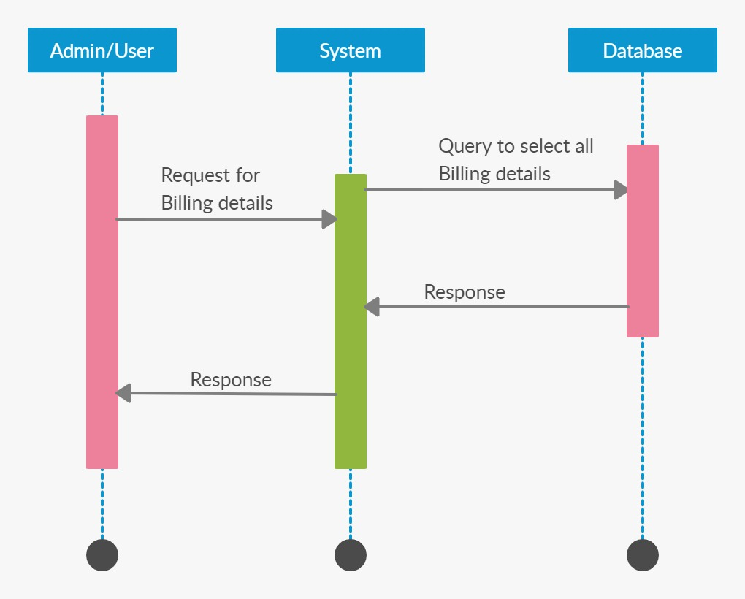

*Figure 1-11 Sequence Diagram for Billing*

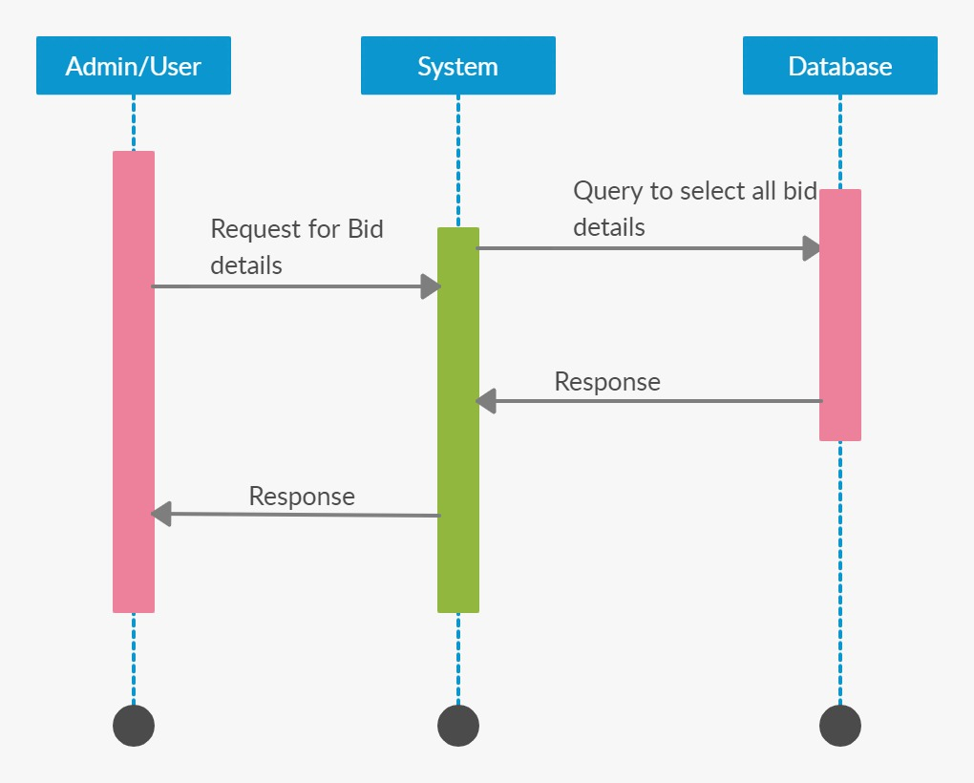

*Figure 1-12 Sequence Diagram for Bidding*

### DFD Levels Diagrams

#### 

Figure 1-13: System DFD level 0

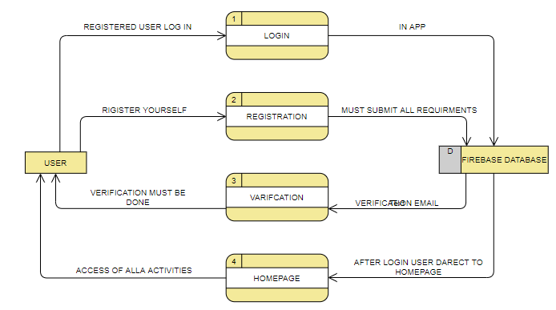

Figure 1-14: System DFD level 1 User Login

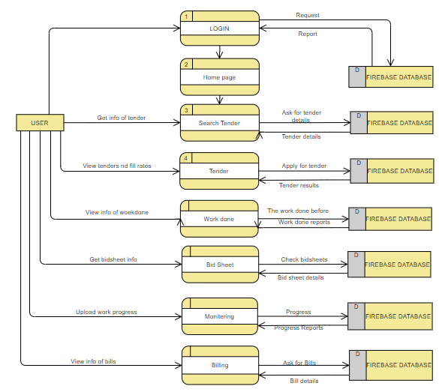

Figure 1-15: System DFD level 2 User

## 

# Chapter 5

**IMPLIMENTATION**

1. **Implementation**

In this chapter, we will discuss the techniques and tools we use to develop the project. This phase is the most prominent phase of development; from this step, we transform our idea into a meaningful picture. This is a significant and challenging step toward learning or developing skills. An application is the result of the successful implementation of tools and technologies. Following are the tools and techniques we use during the development of our application.

* 1. **Tools and Technologies**

## Tools

* + - * + Android Studio 4.2
        + MS Word and PowerPoint

## Languages

* + - * + Java
        + xml

## Database

* + - * + Firebase Database
        + Firebase-database:19.5.0
        + Playservices-location:17.1.0
        + Playservices-places:17.0.0
        + Glide
  1. **Development Stages**

After the designing phase, we move towards the developmental phase to have a clear demonstration of the project. In the implementation phase, we will discuss the phases, which we face incrementally during the development of the application. We use a payment method.

## Payment Method Integration (Jazz Cash)

This is a simple all-in-one online bank account. This account works on your phone number. If you are a merchant and you often carry plenty of money then may harm you in a dangerous situation. Or you may need special protection while caring money around.

Hence business dealers can give their mobile number as the bank account number. Ask them to transfer money into a bank account through this Merchant service. In our project the user first pay the tender fee through this payment method and after user can bid on tender.

## Calculations

When the tender admin uploads a new tender and adds tender details. In tender details, there are many rates per item. The system automatically adds all the item rates and shows the user when they bidding on the tender. On the other hand, when the tender bidding date is closed the tender admin clicks on calculate, and assigning the tender will automatically assign to the lowest bidding contractor/ user. This is a simple all-in-one online bank account. This account works on your phone number. If you are a merchant and you often carry plenty of money then may harm you in a dangerous situation. Or you may need special protection while caring money around. Hence business dealers can give their mobile number as the bank account number. Ask them to transfer money into a bank account through this

* 1. **User Interface**

## Splash Screen

A splash screen is a [graphical control element](https://en.wikipedia.org/wiki/Graphical_control_element) consisting of a [window](https://en.wikipedia.org/wiki/Window_(computing)) containing an [image](https://en.wikipedia.org/wiki/Image), a logo, and the current version of the software. A splash screen can appear while a game or program is launching. A splash page is an introduction page on a application.



*Figure 1-16 Splash Screen*

## Login Page

## A login page is a application page or an entry page to application that requires user identification and authentication, regularly performed by entering a username and password combination. Logins may provide access to an entire site or part of a application.

## 

## *Figure 1-17 Login Page*

## Signup

If the user doesn’t have their account in-app then the user must register first and after signup, the user can log in. For signup, the user must give the valid email, password, and other data and after a click on signup, the user gets a verification email after verifying the user can log in.

## 

## *Figure 1-18 Signup page*

## Email Verification

## 

## *Figure 1-19 Email verification*

## Forget Password

## In case the user forgets their password there is an option for resetting your password through email.

## 

## *Figure 1-20 Forget password*

When the user put their email address the user get the reset password link on the given email address.

## 

## *Figure 1-21 Reset password email*

## Dashboard Screen and navigation bar

A dashboard is a user interface that, somewhat resembling an automobile's dashboard, organizes and presents information in a way that is easy to read. When the user login there is a dashboard screen with different functions.

In Navigation Bar there is a user profile and the user can easily access the tender type in which they are interested. I.e. Roads, Buildings, Streets, and at last there is a sign-out button.

## 

## *Figure 1-22 Dashboard screen and navigation bar*

## 

## Profile

In profile, the user uploads their image or shows data like name, email, and phone number. Users also can change or update their information.

## 

## *Figure 1-23 Profile*

## Search and tenders

In search, users can search tenders by categories like roads, streets, and buildings or places. On the other hand in tender users find all the tenders uploaded by admin and view the details of tender and get the bid sheet in details and bid by getting information about tender.

## 

## *Figure 1-24 Search Tender and tenders*

When the user checks all the tenders and if the user clicks on one tender there is more detail about tender now there is one more button of view detail. If the user is interested then click on view details and get the bid shit on their screen.

## 

## *Figure 1-25 Tenders Details and bid sheet*

After reading or understanding the tender if the user is interested they can bid on it simply the user clicks on the bid button. When the user clicks on the bid button there is the platform of jazz cash where the user first pays the tender fee and then bid on tender. Then the user selects the mobile account option and enters the number and sends the money through jazz cash.

## 

## *Figure 1-26 Jazz Cash and sending tender fee*

When the user sending the tender fee the user can bid on the tender. Now the user fills the rate and waits for tender admin and when the tender admin calculates and assigns the tender, the billing admin has to verify that the user pays their tender fee against the bidding tender. After verification of the billing admin, the project/ tender is assigned to the user.

## 

## *Figure 1-27 bidding on tender*

## Monitoring

## 

When the project is assigned to the contractor/user the assigned tender is shown in bids and they have to start their work and upload images and laboratory tests. After Uploading the image and laboratory test report the monitoring admin monitor the work and verify the work. When the work is verified by the monitoring admin then the billing admin passes the bills and the user collects their checks from the office manually.

## 

## *Figure 1-28 Monitoring*

.

## Billing

## In billing when the billing admin passes the bills the user gets the notification of passed bills and when the user/ contractor collects the checks there will be notification “Congratulation! Payment collected”.

## 

## *Figure 1-29 Billing*

## Work Done

When the monitoring admin passes the project then project details go to billing and the user work done box.

## 

## *Figure 1-30 Work done*

* 1. **Admins Interface**

## Tender Admin

There is an admin who handles the tenders. The tender admin uploads new tender and tender details. There is a tick mark on the right side of the screen by clicking on it tender admin can upload a new tender with tender basic details.

## 

## *Figure 1-31 Tender Admin*

## There is bid sheet where the tender admin add new item details and descriptions with government rates.

## 

## *Figure 1-32 Bid sheet details*

There is Add tender detail from where tender admin add tender details/ bid sheet and tender admin upload new tender with basic details.

## 

## *Figure 1-33 Add tender details*

## 

## *Figure 1-34 Add Tender*

The tender admin finds the bids by contractor/ user and assigns them by clicking on calculation and assigning. On the other hand, the tender admin gets notifications from the user who bids on the new tender.

## 

## *Figure 1-35 Bids and Notifications*

## Monitoring Admin

Monitoring admin is that who handles the monitoring or project. The monitoring admin gets the project details from the contractor/ user in form of pictures and also a laboratory test of the material/ project. The monitoring admin monitors the work and checks the laboratory test. After monitoring the admin give feedback to the contractor/user in the chat

## 

## *Figure 1-36 Monitoring Admin*

## 

## *Figure 1-37 Monitoring and feedback*

## Billing Admin

When the monitoring admin passes the project and clicks on the mark as complete then the project added in work done and the billing admin releases the payment. When the billing admin clicks on release payment the user/ contractor gets the notification “Your check is ready to get from office / visit the office. After collecting the payment the billing admin click on collected the user again get the notification “you collected you payment against XYZ project.

## 

## *Figure 1-38 Billing Admin*

# Chapter 6

**Testing and Evaluation**

1. **Testing and evaluation**
   1. **Manual Testing**

Once we create any application we must check or analyze its features so that when it gets delivered, it is free of error, bugs, and other issues. The process of testing any software manually. To ensure completeness of testing. By following some written test plan that leads it to test cases. The test cases are done one by one by a person who is involved in the testing phase or testers. It is done in an automated way without using any tool. The main purpose of manual testing is to resolve or fix bugs and issues in software. It is the most primitive technique that helps to find bugs in the application. Every new application must be tested manually first. The two main reasons for ensuring the quality of software are given below:

* Finding out errors that arise during running the application.
* Check that the application fulfills the system requirement or not

## System testing

System testing validates the integrated software product. It takes an input of all integrated components. It is performed on the entire system.it tells the expectation of the customer. It tells us the actual result or behavior of the product when the system is tested. In our system, we will test that all functions and calculations are correctly or not we check the tenders searching, tenders and biddings, work done, monitoring, notifications, billings and then finalized our project after all testing of our android application.

## Unit Testing

In unit testing, the smallest part of an application is tested independently. We check each unit of our system in accordance with user requirements. We check each piece of code to check the continuity and flow of an application. Every module has a relation with the previous and next steps. We can find errors by inspect code by click on analyze after the inspection result, we can see detailed errors and warnings messages. USB debugging mode helps to the copied the app via USB to the device for testing. We also faced several exception handlings during done this project. Unit testing for the whole application has been mentioned.

## Function Testing

In functional testing, we generate test cases to check the functionality of each part and its accuracy compared with the actual outcome. It is the stage where we analyze the accuracy of the application as correct or not. We not only tried to make every functionality performing but also had a focus on making it easy and attractive. We went through the complete process of testing. Starting with user authentication, log in through the app, and see all the results that happen in the app. Admin is responsible for managing data firebase. They are performed to check the usefulness of the application from the user point of view.

* + - 1. **Test Cases Results**

Test Cases and Results Test cases are created for each of the functional requirements. These test cases provide the action to test case; expected results and actual results along with test Fail/Pass remarks.

* + - 1. **User Sign-in**

Objective: To ensure Sign in working correctly

**Table** **6-1 user Sign-in**

|  |  |  |  |  |
| --- | --- | --- | --- | --- |
| **No** | **Action** | **Expected results** | **Actual results** | **P/F** |
| **1** | Click on the Login button without  filled the Email Address | Highlight as required fields | Highlight as required fields | **P** |
| **2** | Enter an unregistered | Highlight as enter registered Email | Highlight as enter registered email | **P** |
| **3** | Enter the wrong email | Highlight as a show error message | Highlight as a show error message | **P** |
| **4** | Enter the registered email and password | Successfully login | Successfully login | **P** |

* + - 1. **User Sign-up**

Objective: To ensure Sign-up working correctly

**Table** **6-2 User Sign-up**

|  |  |  |  |  |
| --- | --- | --- | --- | --- |
| **No** | **Action** | **Expected results** | **Actual results** | **P/F** |
| **1** | Click on signup  With empty fields. | Highlight as required fields | Highlight as required fields | **P** |
| **2** | Enter wrong email address | Highlight as required correct email Address. | Highlight as required correct email Address. | **P** |
| **3** | Enter the wrong Password | Highlight as  entering a correct password | Highlight as the wrong input. | **P** |
| **4** | Enter wrong verification code | Highlight as error | Showed error message | **P** |

* + - 1. **Search Tender**

Objective: To ensure tenders searching is working correctly

**Table 6-3 User Search tender**

|  |  |  |  |  |
| --- | --- | --- | --- | --- |
| **No** | **Action** | **Expected results** | **Actual results** | **P/F** |
| **1** | Click on Search tender box | New activity open | New activity open | **P** |
| **2** | Search by Category (Road, streets, buildings) | Successfully search | Successfully search | **P** |
| **3** | Search by place | Successfully search | Successfully search | **P** |
| **4** | Click on cross sign or back | Successfully work | Successfully work | **P** |

* + - 1. **Tenders**

Objective: To ensure tenders is working correctly

**Table 6-4 User tenders**

|  |  |  |  |  |
| --- | --- | --- | --- | --- |
| **No** | **Action** | **Expected results** | **Actual results** | **P/F** |
| **1** | Click on tender box | New activity open | New activity open | **P** |
| **2** | All tender shown uploaded by admin | Successfully work | Successfully work | **P** |
| **3** | View Details of any tender | Successfully shown | Successfully shown | **P** |
| **4** | Click on cross sign or back | Successfully work | Successfully work | **P** |

* + - 1. **Bid on tender**

Objective: To ensure bid on tender is working correctly

**Table 6-5 User bid on tender**

|  |  |  |  |  |
| --- | --- | --- | --- | --- |
| **No** | **Action** | **Expected results** | **Actual results** | **P/F** |
| **1** | Click on tender details | New activity open | New activity open | **P** |
| **2** | View Bid button bellow | Successfully shown | Successfully shown | **P** |
| **3** | Click on bid button | Go to jazz cash platform | Successfully goes to jazz cash platform | **P** |
| **4** | Select mobile account and fill mobile number | Successfully selected or filled | Successfully selected or filled | **P** |
| **5** | Click on pay | Successfully pay | Successfully pay | **P** |
| **6** | Bidding field shown and fill your rate | Successfully shown and bided | Successfully shown and bided | **p** |
| **7** | Click on cross sign or back | Successfully work | Successfully work | **P** |

* + - 1. **Monitoring**

Objective: To ensure tender monitoring is working correctly

**Table 6-6 User monitoring**

|  |  |  |  |  |
| --- | --- | --- | --- | --- |
| **No** | **Action** | **Expected results** | **Actual results** | **P/F** |
| **1** | Click on monitoring box | New activity open | New activity open | **P** |
| **2** | Attached file / image filed shown | Successfully | Successfully | **P** |
| **3** | Click on upload button without attaching file / image | Error message shown “at least one file or image attached “ | Successfully worked | **P** |
| **4** | Attach file/ image go to device files / gallery | Successfully | Successfully worked | **p** |
| **5** | Click on upload with image / file | Uploaded | Successfully |  |
| **6** | Click on cross sign or back | Successfully work | Successfully work | **P** |

* + - 1. **Billing**

Objective: To ensure tenders billing is working correctly

**Table 6-7 User billing**

|  |  |  |  |  |
| --- | --- | --- | --- | --- |
| **No** | **Action** | **Expected results** | **Actual results** | **P/F** |
| **1** | Click on billing box | New activity open | New activity open | **P** |
| **2** | Get notifications of passed bills and collected bills | Successfully get | Successfully worked | **P** |
| **3** | Click on cross sign or back | Successfully work | Successfully work | **P** |

* + - 1. **Work done**

Objective: To ensure work done is working correctly

**Table 6-8 User work done**

|  |  |  |  |  |
| --- | --- | --- | --- | --- |
| **No** | **Action** | **Expected results** | **Actual results** | **P/F** |
| **1** | Click on work done box | New activity open | New activity open | **P** |
| **2** | Those work/project you did the tender details are in work done | Successful | Successful | **P** |
| **3** | Click on cross sign or back | Successfully work | Successfully work | **P** |

* + - 1. **Navigation bar**

Objective: To ensure Navigation bar is working correctly

**Table 6-9 User navigation**

|  |  |  |  |  |
| --- | --- | --- | --- | --- |
| **No** | **Action** | **Expected results** | **Actual results** | **P/F** |
| **1** | Click on Navigation icon on left top corner | New side bar come | New side bar come | **P** |
| **2** | Click on profile upload user image or update details | Image uploaded and updated details | Image uploaded and updated details | **P** |
| **3** | Click on streets, buildings, roads one by one | Tender shown by category | Successfully worked | **P** |
| **4** | Click on sign out | Sign out successfully | Sign out successfully | **p** |
| **5** | Click on cross sign or back | Successfully work | Successfully work | **P** |

* + - 1. **Logout**

Objective: To ensure user log-out working correctly

**Table** **6-10 Log-out**

|  |  |  |  |  |
| --- | --- | --- | --- | --- |
| **No** | **Action** | **Expected results** | **Actual results** | **P/F** |
| **1** | Click logout sign on top right corner | Log out | Logged out | **P** |

* + - 1. **Tenders Admin**

Objective: To ensure tenders Admin is working correctly

**Table 6-11 Tender admin**

|  |  |  |  |  |
| --- | --- | --- | --- | --- |
| **No** | **Action** | **Expected results** | **Actual results** | **P/F** |
| **1** | Click on the Login button without  filled the Email Address | Highlight as required fields | Highlight as required fields | **P** |
| **2** | Enter the wrong email | Highlight as a show error message | Highlight as a show error message | **P** |
| **3** | Enter the registered email and password | Successfully login | Successfully login | **P** |
| **4** | All tender shown uploaded by admin | Successfully work | Successfully work | **P** |
| **5** | Click on tick mark on below right corner | New activity open | New activity open | **P** |
| **6** | For adding new tender fill all the fields | All fields filled | All fields filled | **p** |
| **7** | Click add tender button before filling all field | Highlight as a show error message | Highlight as a show error message | **p** |
| **8** | Click on view details button | New activity open | New activity open | **p** |
| **9** | Click on tick mark on below right corner | Add tender details/ bid sheet | Add tender details / bid sheet | **p** |
| **10** | Click add tender details button before filling all field | Highlight as a show error message | Highlight as a show error message | **p** |
| **11** | Click on view bids | Show all user/ contractors bids | Show all user/ contractors bids | **p** |
| **12** | Click on calculate and assign button | Automatically calculate and assign tender of lower bid contractor / user | Automatically calculate and assign tender of lower bid contractor / user | **p** |
| **13** | Click on bell icon on right top corner | Show all the notifications or user bids and new tenders | Show all the notifications or user bids and new tenders | **p** |
| **14** | Click on cross sign or back | Successfully work | Successfully work | **P** |

* + - 1. **Monitoring Admin**

Objective: To ensure monitoring Admin is working correctly

**Table 6-12 Monitoring admin**

|  |  |  |  |  |
| --- | --- | --- | --- | --- |
| **No** | **Action** | **Expected results** | **Actual results** | **P/F** |
| **1** | Click on the Login button without  filled the Email Address | Highlight as required fields | Highlight as required fields | **P** |
| **2** | Enter the wrong email | Highlight as a show error message | Highlight as a show error message | **P** |
| **3** | Enter the registered email and password | Successfully login | Successfully login | **P** |
| **4** | All tender shown assigned by tender admin | Successfully work | Successfully work | **P** |
| **5** | Click on view details button | New activity open | New activity open | **p** |
| **6** | Show all the pictures and laboratory tests uploaded by specific user | Successfully work | Successfully work | **P** |
| **7** | Click on message icon on top right corner | Give feedback to user by chat | Give feedback to user by chat | **p** |
| **8** | From user side message received from monitoring admin | Successfully work | Successfully work | **P** |
| **9** | Click on mark as complete | Tender goes to user work done and billing admin | Tender goes to user work done and billing admin | **p** |
| **10** | Click logout sign on top right corner | Log out | Logged out | **P** |

* + - 1. **Billing Admin**

Objective: To ensure billing Admin is working correctly

**Table 6-13 Billing admin**

|  |  |  |  |  |
| --- | --- | --- | --- | --- |
| **No** | **Action** | **Expected results** | **Actual results** | **P/F** |
| **1** | Click on the Login button without  filled the Email Address | Highlight as required fields | Highlight as required fields | **P** |
| **2** | Enter the wrong email | Highlight as a show error message | Highlight as a show error message | **P** |
| **3** | Enter the registered email and password | Successfully login | Successfully login | **P** |
| **4** | Show all the tenders mark as completed by monitoring admin | Successfully work | Successfully worked | **p** |
| **5** | Click on view details | Show tender details / bid sheet | Show tender details/ bid sheet | **p** |
| **6** | Click on release payment | User get notification of releasing payment against xyz project/tender | User get notification of releasing payment against xyz project/tender | **p** |
| **7** | After clicking on release payment | Button change to collected | Button change to collected | **p** |
| **8** | Click on collected | User get notification when they collect the payment | Get notification again about collecting payment | **p** |
| **9** | Admin approve the tender fee pay by user | Successfully work | Successfully worked | **P** |
| **10** | Click on bell icon | Get notifications about new verifications or releasing payment | Get notifications about new verifications or releasing payment | **p** |
| **11** | Click logout sign on top right corner | Log out | Logged out | **P** |

**CHAPTER 7**

**Conclusion and Future Work**

1. **Conclusion**

## Conclusion

Due to the fast changes in the era of computerized technology we need to convert manual systems to automated systems. Our “E-Tendering” application helps the contractors and government construction departments. Our application makes it easy to bid on tenders anywhere, the admin simply uploads the tender in-app and the contractors bid on it from their homes or any place in the world. This application helps contractors in time, fuels, and their important time to come PHE department for tender bid.

There is no such app that guides the contractors using such a technique we used for bidding easily. Contractors come out of their precious time just to bid but it is not confirmed that the tender will be found or not. Sometimes the contractor is in an emergency so he can't do a tender bid. So, that’s why we created this application that will help the contractor to bid from the house and this will save the contractor time, petrol, and other expenses.

## Future work

The following can be implemented as future Work.

1. We will relate this application with different departments i.e. PWD, NHA, and local government the application updated with departments.

2. We also can add the registration in the department through license the contractor give documents and their license for registration online.

3. Make a website for E- tendering and monitoring.

4. We will add more functionalities in this application (i.e.) Add bank accounts and other payment methods.

5. Add check collection system also online, payments directly send to contractor account.

6. Use Map for tender place visiting and tender city departments.

## 

**CHAPTER 8**

**References**

## References

1. <https://www.google.com/search?q=submitted+to+higher+education+commission+pakistan&rlz=1C1CHBD_enPK921PK921&oq=submitted+to+higher+education+commission+pakistan&aqs=chrome..69i57.15562j1j7&sourceid=chrome&ie=UTF-8>
2. <https://www.google.com/search?q=Submitted+to+Myanmar+Computer+Company+Ltd+(MCC)+-+Yatanarpon&rlz=1C1CHBD_enPK945PK945&oq=Submitted+to+Myanmar+Computer+Company+Ltd+(MCC)+-+Yatanarpon&aqs=chrome..69i57.812j0j9&sourceid=chrome&ie=UTF-8>
3. <https://www.javatpoint.com/>
4. <https://en.wikipedia.org/wiki/Main_Page>
5. <http://www.arabou.edu.sa/en/>
6. [www.youtube.com](http://www.youtube.com)
7. [UbiCC - the world's leading professional association for the advancement of technology](http://www.ubicc.org/)
8. <http://shahdeepinternational.com/>
9. <https://www.google.com/search?q=Submitted+to+Asia+Pacific+University+College+of+Technology+and+Innovation+(UCTI)&rlz=1C1CHBD_enPK945PK945&oq=Submitted+to+Asia+Pacific+University+College+of+Technology+and+Innovation+(UCTI)&aqs=chrome..69i57.783j0j9&sourceid=chrome&ie=UTF-8>



